# Work breakdown structure (WBS)

**BookLovers**

Testing

Designing product

Deployment

Requirement

Implementation

Designing prototype

User acceptance

Statement for scope

Programming

Functional testing

Unit testing

Designing user interface

Work Breakdown Structure

Project scheduling

Client feedback

**Figure 3: WBS structure for this project**

**Gantt chart**

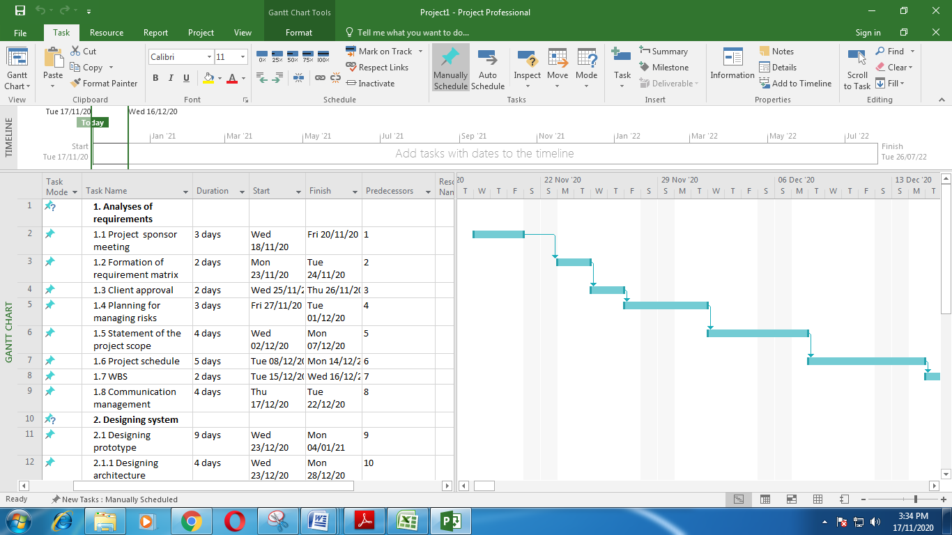

**Figure 4: Gantt chart**

# Management plans for assessing risks

Every project has various kinds of risks associated with it. As per Kononenko and Lutsenko (2017, p.10), different types of risks can affect profitability margin in the business. Opening an online bookstores project is full of risks as they impact negatively organisational performance. These risks can be:

* ***Risks related to project scheduling***
* ***Risks related to new programming***
* ***Risks related to customer feedback***
* ***Intellectual properties of e-commerce***

# A risk register for this project

|  |  |  |  |  |  |  |
| --- | --- | --- | --- | --- | --- | --- |
| **Name of risks** | **Description of risks** | **Category of risks** | **Identified date** | **Status** | **Rating of risks** | **Process for mitigation** |
| Risks related to new programming | According to Sharon and Dori (2017, p.450), customers may not like new outlooks and designs of the website. Hence, Fishpond can lose customers. | Risks related to people | 17/11/2020 | This process has not started yet | High | The project needs to include feedback from customers. It can help to increase the quality of programming |
| Risks related to project scheduling | Team members may be unable to complete this project in scheduled duration. | Risks related to project | 20/11/2020 | This process has been completed | Moderate | Every task needs to be classified according to the work schedule. |
| Disputes with customers | Customers can complain about taking wrong orders and getting incorrect deliveries (Tereso *et al.* 2019, p.10). Risks can come from product quality, retailer shipping, and delivery. Few technical errors can be observed, as well. | Risks related to service and business | 23/11/2020 | It has not started yet | High | Exchange and refund policies need to be cleared. |
| Intellectual properties of e-commerce | Every material has its own industrial property code. These are copyrighted, and the online website can face legal issues. | Risks related to business | 26/11/2020 | This task has been completed | Moderate | Intellectual properties need to be safeguarded to mitigate legal risks |

**Table 2: Risk register for this project**